**Business Term Approval Workflow**

**Deployment Documentation**

**Application Version History**

|  |  |  |  |
| --- | --- | --- | --- |
| **Application Version** | **Released On** | **Released By** | **Approved By** |
| 1.0 | 02-09-2020 | N. Padma Gokul |  |

# 

# 

# 

# **Contents**

[**1. Overview**](https://docs.google.com/document/d/1DqVuA1M_ofZBnRHXTiHPNxzSvBHyPwH02r1RRQ9LkbE/edit#heading=h.abc46wlrpe73)[**4**](https://docs.google.com/document/d/1DqVuA1M_ofZBnRHXTiHPNxzSvBHyPwH02r1RRQ9LkbE/edit#heading=h.abc46wlrpe73)

**2. Workflow Deployment 4**

**3. Configurations 5**

**3.1 Business Term Proposal Workflow 8**

**3.2 Business Term Approval Workflow 10**

**3.3 Approval Custom Voting Subprocess 13**

**4. Settings 14**

**4.1 Dashboard Settings 14**

# **Overview**

This document lists the steps involved in deploying & configuring the following workflows

* Propose Business Term Workflow
* Custom Approval Process Workflow
* Approval Voting Sub Process Workflow

# **Workflow Deployment**

* Login to Collibra DGC.
* Navigate to “Settings -> Workflows” and click on upload workflow.
* In the package folder, go to “Business Term Approval Workflow -> Workflow -> Business Term Approval -> src -> bpmn” and select the bpmn files one by one and click upload.
* The bpmn files will be uploaded to the DGC.

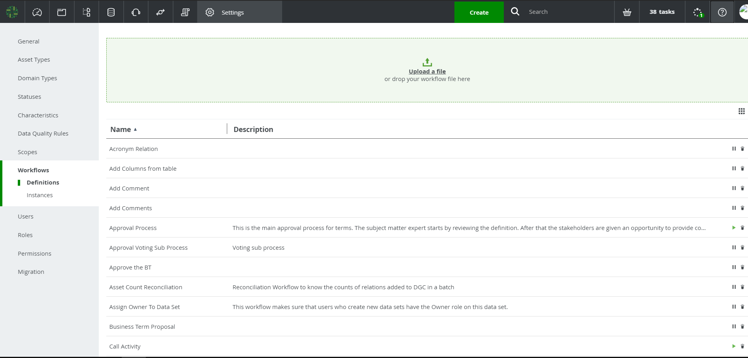

# **Configuration**

* Now scroll down the workflow page and enable “Propose Business Term Workflow”, “Custom Approval Workflow” and “Approval Voting Sub Process” by clicking on the play button  adjacent to it.
* Now go to “Settings -> Roles -> Resources” and click on the “Add” button.

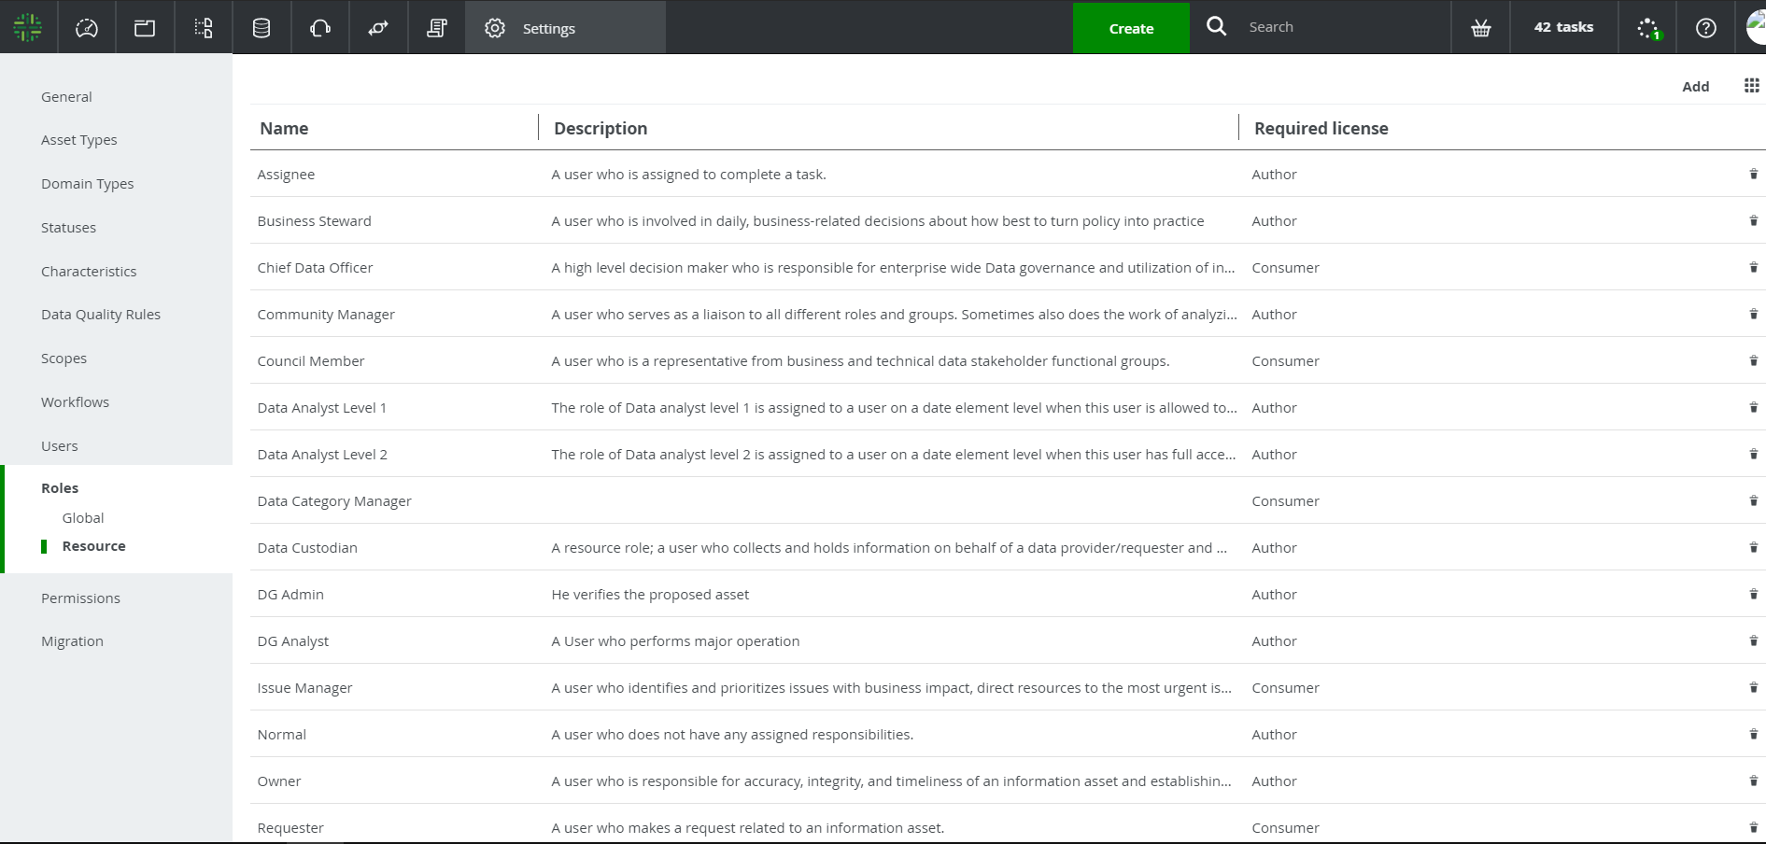

* Create roles named “DG Admin”, “DG Analyst” and “Technical Steward” one by one with description as optional.
* Now click on the “Dashboard” icon and in the dashboard, click on the “Create” button.

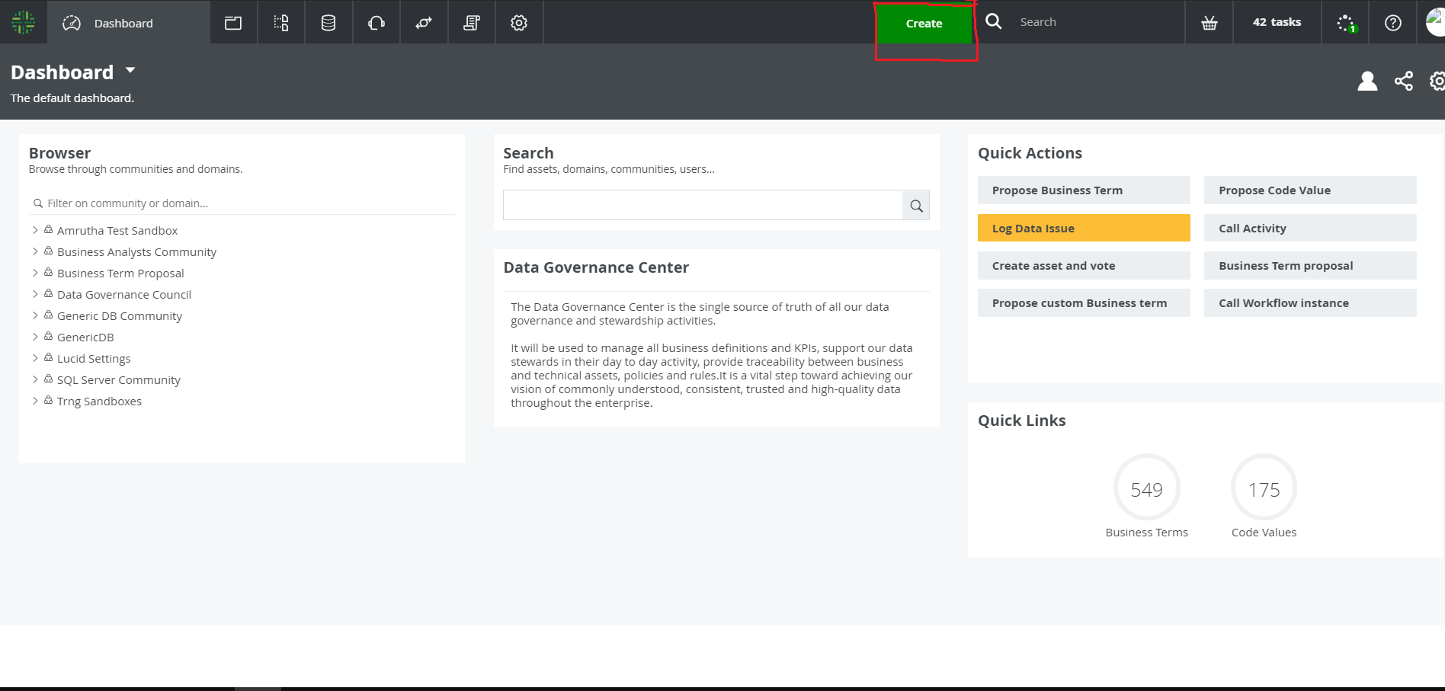

* Go to “Organization” and select community. Name the community of your choice.

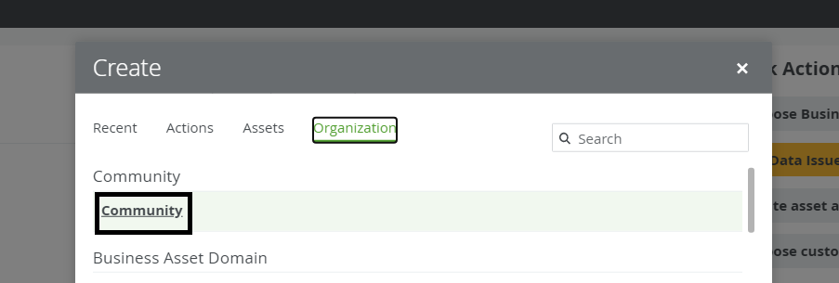

* Now again click on the “Create” button and go to “Organization” and search for “Glossary”. Name the domain of your choice and for the “Community” field select the newly created community. This domain will house the proposed business term temporarily before approval.
* To assign responsible users for the domain, search for the required domain and select it. Then go to the responsibility section in the left hand side and click “add a user or group”.

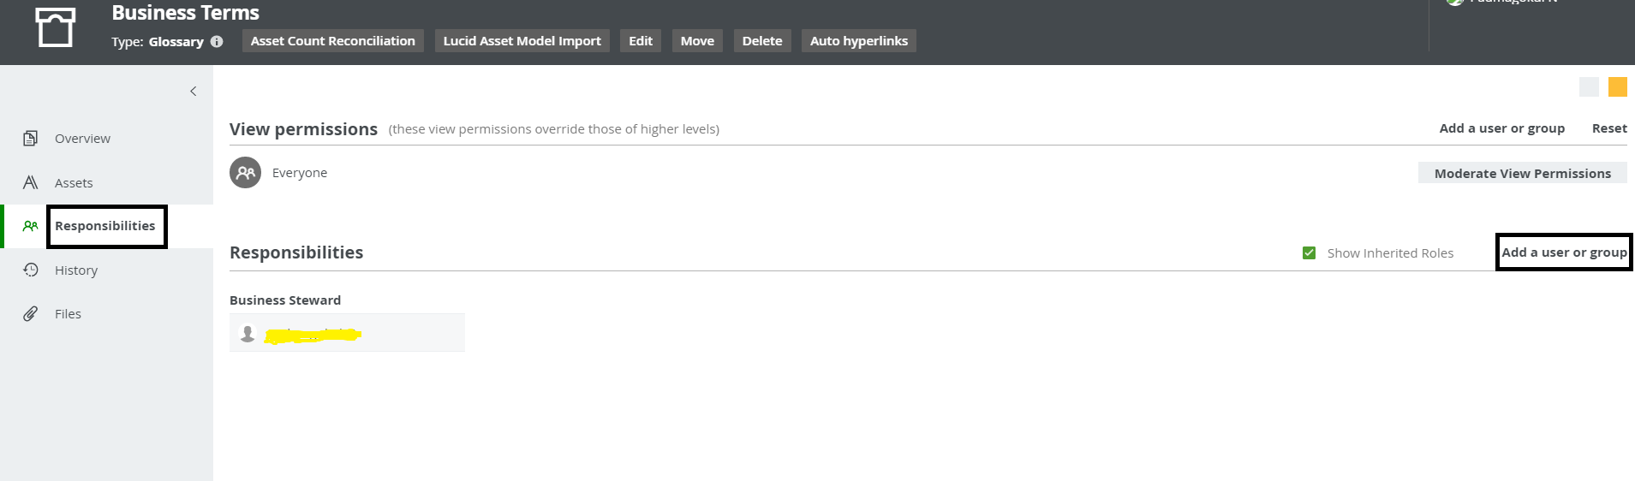

* For the role select “DG Admin” and for “people”, select the required users for the role and click ok.

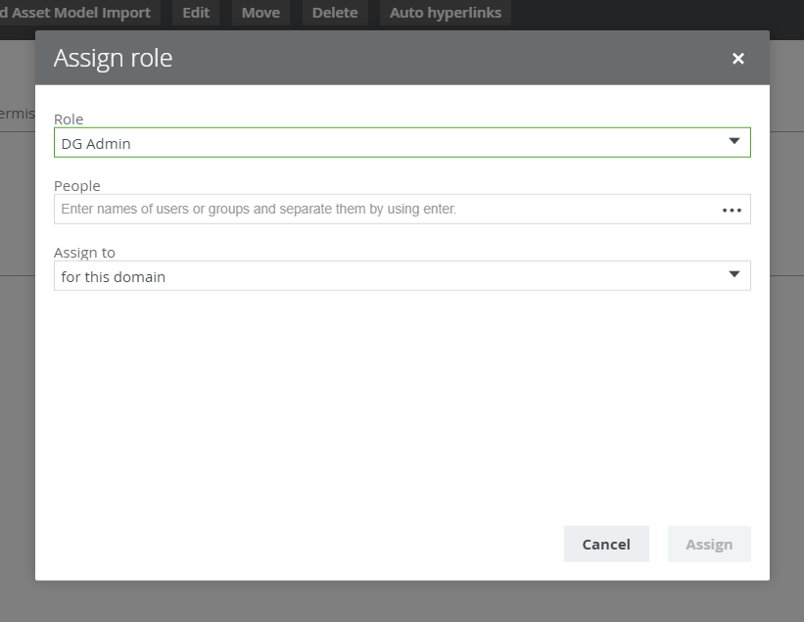

* Repeat the process for all the other roles and for any newly created Glossary Domains.

## **3.1 Business Term Proposal Workflow**

* Now go to “Settings -> Workflow” and select “Propose Business Term Workflow”. In the “Workflow Variables” section, select the “Pencil” icon and in the field “Intake Vocabulary” enter the name of the temporary domain created.

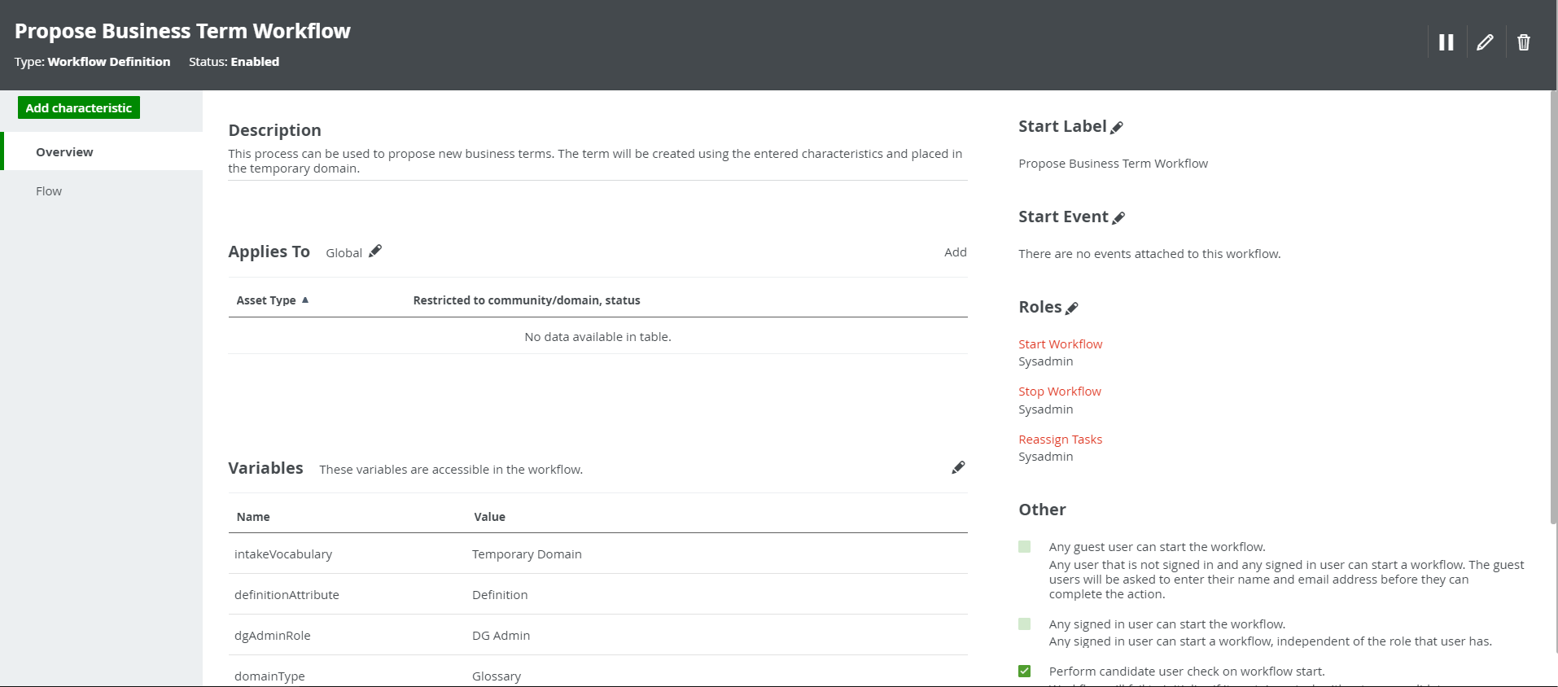

**Workflow Variables:**

|  |  |  |  |  |
| --- | --- | --- | --- | --- |
| **S. No** | **Variable** | **Out of The Box (OOTB) / Custom** | **Default** | **Description** |
| 1 | Domain where the asset is created | Custom | Temporary Domain | The domain name where the proposed asset is created |
| 2 | Definition Attribute | Custom | Definition | Definition attribute name, which is used to show the definition given by proposer in the asset |
| 3 | Note Attribute | Custom | Note | Definition attribute name, which is used to show the definition given by proposer in the asset |
| 4 | Type of Asset | Custom | Business Term | Type of asset to be created |
| 5 | Name of the workflow to be called | Custom | customApprovalWorkflow | Process Id of the workflow to be called (Do not modify this) |
| 6 | Domain Type | Custom | Glossary | Domain type for fetching the responsible user from the domain(Do not modify this) |
| 7 | DG Admin | Custom | DG Admin | Role name for assigning task to the user (Do not modify this) |

## **3.2 Business Term Approval Workflow**

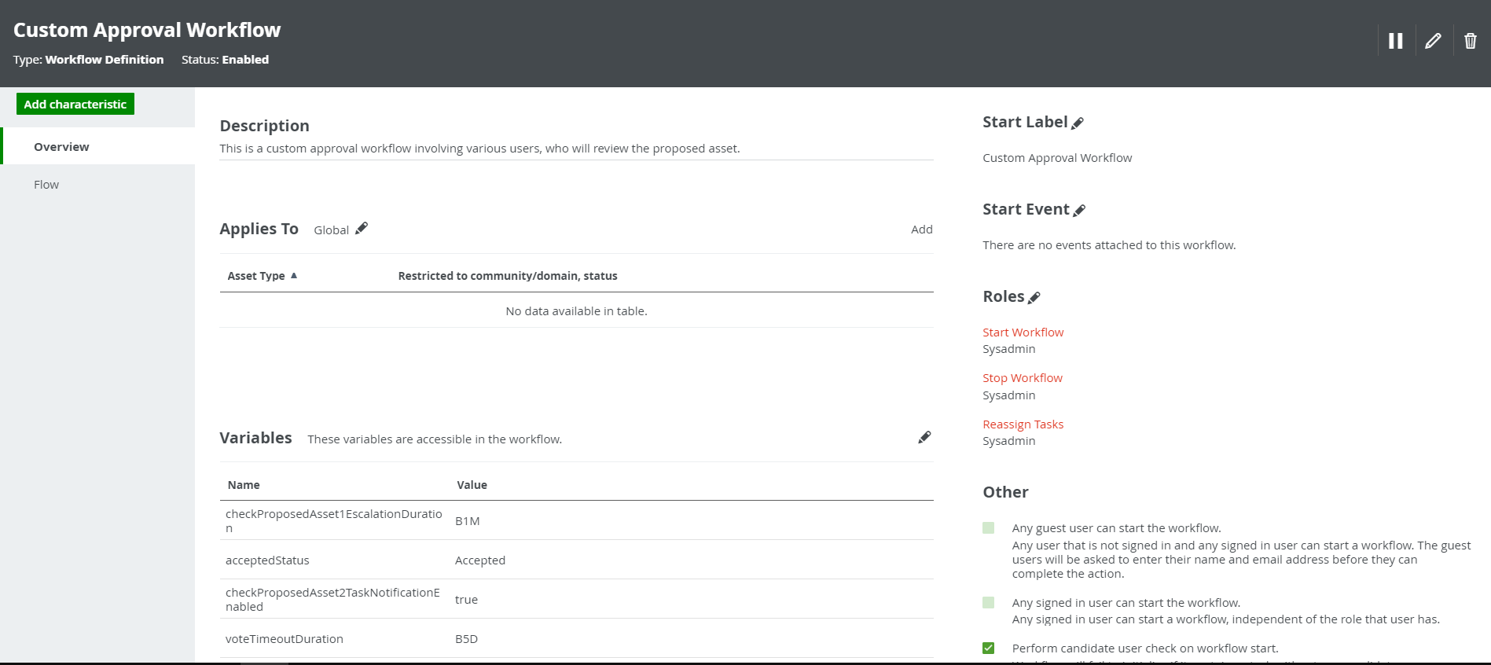

**Workflow Variables:**

|  |  |  |  |  |
| --- | --- | --- | --- | --- |
| **S. No** | **Variable** | **Out of The Box (OOTB) / Custom** | **Default** | **Description** |
| 1 | Under Review Status | Custom | Under Review | Status of the asset to be set after proposal. |
| 2 | Asset ID | Custom | outputCreatedTermId | Asset Id of the proposed asset.(Do not modify this) |
| 3 | Accepted Status | Custom | Accepted | Status of the asset to be set after approval. |
| 4 | Rejected Status | Custom | Rejected | Status of the asset to be set after rejection. |
| 5 | Acronym Relation | Custom | has acronym | Relation name to relate an asset to an acronym |
| 6 | Column Relation | Custom | is part of | Relation name to relate an asset to a column |
| 7 | Represents Relation | Custom | represents | Relation name to relate an table to a column |
| 8 | Acronym Relation Source Type | Custom | Business Asset | Relation head name to get the relation ID |
| 9 | Acronym Relation Target Type | Custom | Acronym | Relation tail name to get the relation ID |
| 10 | Column Source Type | Custom | Column | Relation head name to get the relation ID |
| 11 | Technical Steward | Custom | Technical Steward | Role name for assigning task to the user (Do not modify this) |
| 12 | Business Steward | Custom | Business Steward | Role name for assigning task to the user (Do not modify this) |
| 13 | Vote Completion Percentage | Custom | 100 | Minimum percentage of vote required to complete the voting process. You can modify this to your choice. |
| 14 | Acronym Concept Type | Custom | Acronym | For suggesting only acronyms when selecting acronym relation to add(Do not modify this) |
| 15 | Table Concept Type | Custom | Table | For suggesting only tables when selecting table relation to add(Do not modify this) |
| 16 | DG Analyst | Custom | Technical Steward | Role name for assigning task to the user (Do not modify this) |
| 17 | Vote Completion time | Custom | B5D | Deadline for business stewards to complete the vote |

* Vote Completion time - This specifies the deadline for business stewards to complete the vote. The default is B5D(5 Business Days). It can be modified in the workflow variables.

## **3.2 Approval Voting Sub-Process**

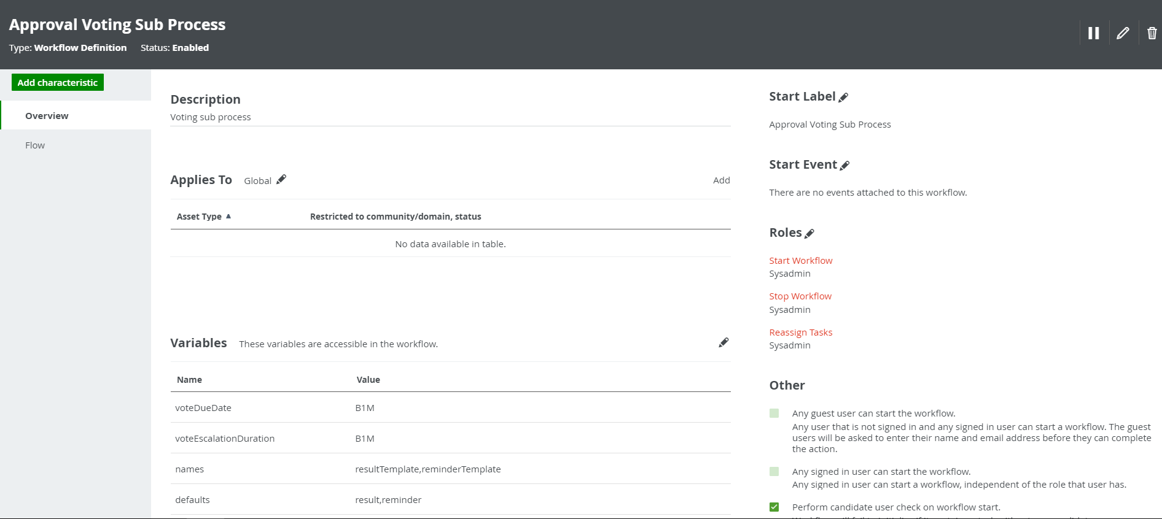

**Workflow Variables:**

|  |  |  |  |  |
| --- | --- | --- | --- | --- |
| **S. No** | **Variable** | **Out of The Box (OOTB) / Custom** | **Default** | **Description** |
| 1 | Time duration before a warning mail is send to vote | Custom | B3D | Deadline for business stewards before a warning mail is sent |
| 2 | Time duration before the voting is stopped and the process continued | Custom | B5D | Deadline for business stewards before the vote is completed |

# **4. Settings**

## **4.1 Dashboard Settings**

The following Workflows must be configured in the dashboard:

* Propose Business Term Workflow

To configure the Workflows in the dashboard, follow the steps below:

1. Click on Dashboard -> Settings -> Edit Widgets

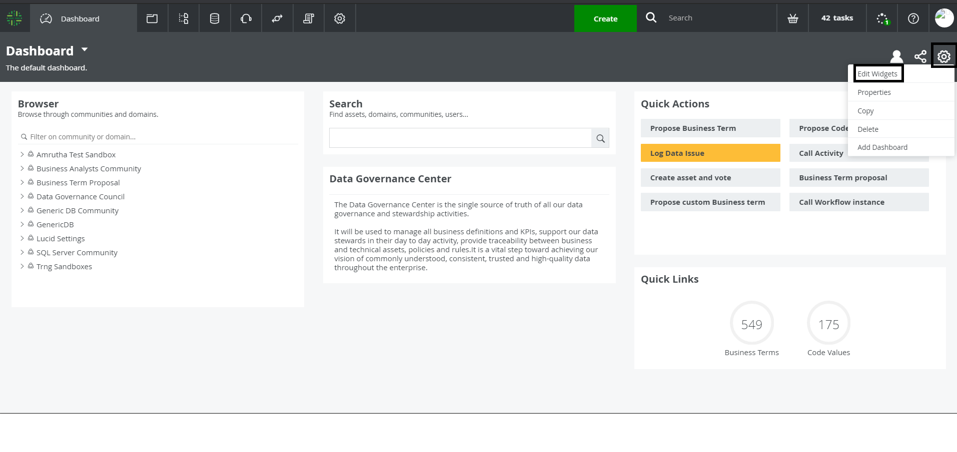

1. Click on the Configure icon  under Quick Actions. Click on Add Button. Enter the name of the button as "Propose Business Term" in the first box and select the required workflow "Propose Business Term Workflow" in the second box. Click on the Save button.

